TC-DISP-003
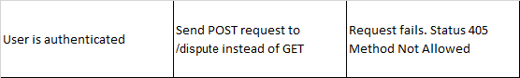
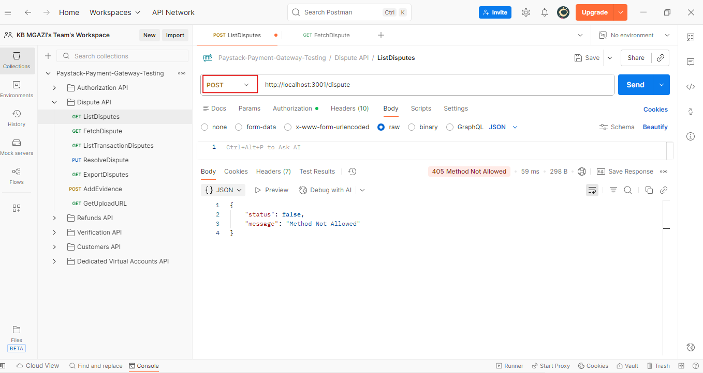
Response:
{
"status": false,
"message": "Method Not Allowed"
}

